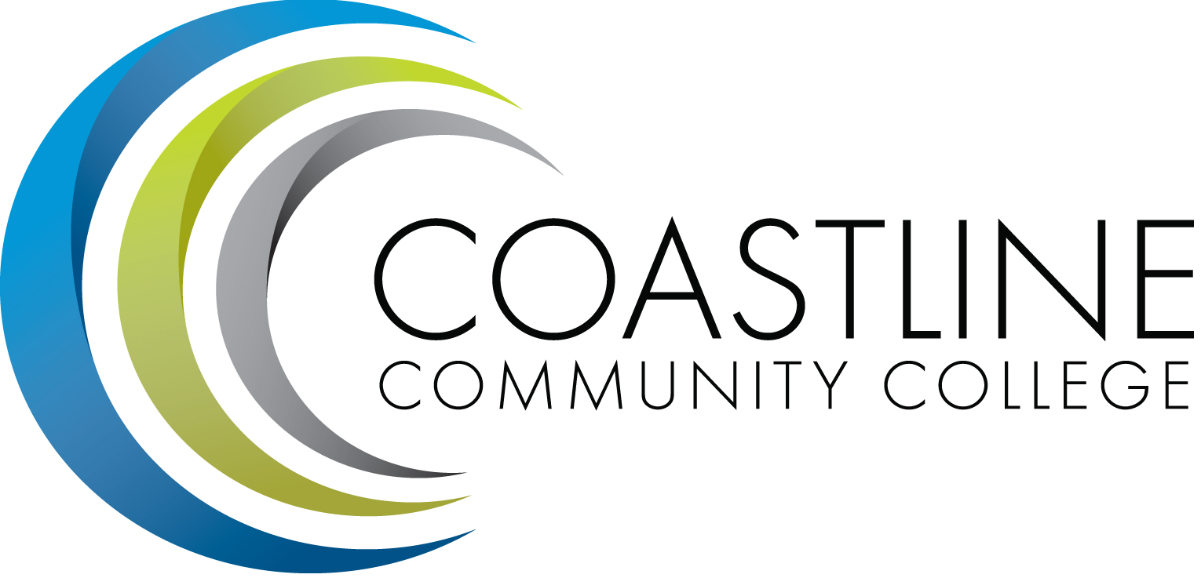
AGENDA
Coastline Management Meeting (CMT)
October 4 2016
9:00 – 11:00 a.m.
4th Floor Conference Room

Committee Mandate: To review and improve College operations and management through sharing information, discussion, and staff development.

- CALL TO ORDER
  - Roll Call
  - Welcome
  - Adoption of October 4, 2016 Agenda
  - Approval of Minutes
- September 6, 2016

- SPECIAL REPORTS & UPDATES
2.1 Adobe Creative Cloud Access (C. Blackmore)

- ACTION ITEMS
  - From March 1, 2016 Meeting:
3.1.1 All members will review Focus Survey results and provide feedback to Aeron by or before the next CMT meeting on April 5 for finalization of the document. DEFERRED TO NEXT MEETING

  - From May 3, 2016 Meeting:
    - The Instruction and Student Services Wing will develop a joint document to identifying two to three areas of focus and an action plan to complete their plan. Vince will provide copy of plan document at the next meeting in June. DEFERRED TO NEXT MEETING
    - Dana and Vince will confer with the Academic Senate to clarify the Senate’s request for definitions and expectations of the Civitas program. They will provide a report at the next meeting in June. DEFERRED TO NEXT MEETING

- STANDING REPORTS (2 minutes per)
4.1 Accreditation – V. Rodriguez
4.2 PIEAC – S. Barnes, V. Rodriguez
4.3 Budget – C. Nguyen
4.4 Academic Senate – S. Barnes
4.5 Classified Senate – K. Donahue
4.6 Associated Student Government (ASG) – N. Brais,
4.7 President’s Report – L. Adrian
4.8 Executive Team Report – J. Groot, R. Miyashiro, C. Nguyen, V. Rodriguez
4.9 HR Report – R. Akins
4.10 Financial Aid Federal Program Review Update
- DISCUSSION ITEMS
5.1 The Rights of Transgender Students (R. Akins, J. De La Rosa) (20 minutes)

- HOT TOPICS

- ANNOUNCEMENTS
8. Managers Retreat Wrap Up (30 minutes)
9. ADJOURNMENT

10. CDMA – CLOSED SESSION
*Attachment

Next Meeting: Tuesday, November 1, 2016

